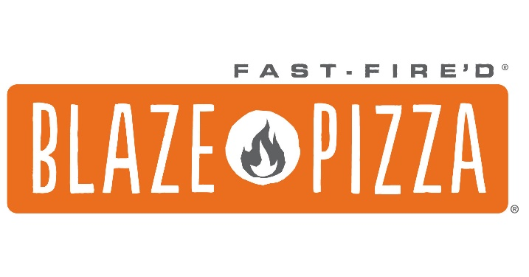

Blaze Pizza will be hosting a Blaze Pizza Fundraiser night on Wednesday March 29, 2023, from 4:00 PM to 8:00 PM for West Boca Raton Softball Association! You can participate in a Blaze Pizza fundraiser in-store for takeout and dine-in, online at blazepizza.com, or by calling in your order!
How to participate? Just visit the restaurant and show your fundraiser flyer and mention the fundraiser at checkout, or order online with the digital coupon code (attached on flyer) on the day of the fundraiser. To order online, head to blazepizza.com. Order from the restaurant located at 20522 SR-7N, Boca Raton, FL 33498, and use the digital coupon code, 1254A. If ordering in-store or over the phone, simply show your digital flyer.
Blaze Pizza will be generously donating 20% back of all sales from Dine-In & Takeout orders to West Boca Raton Softball Association.

Thank you and spread the word…

